**Development process embedded systems**

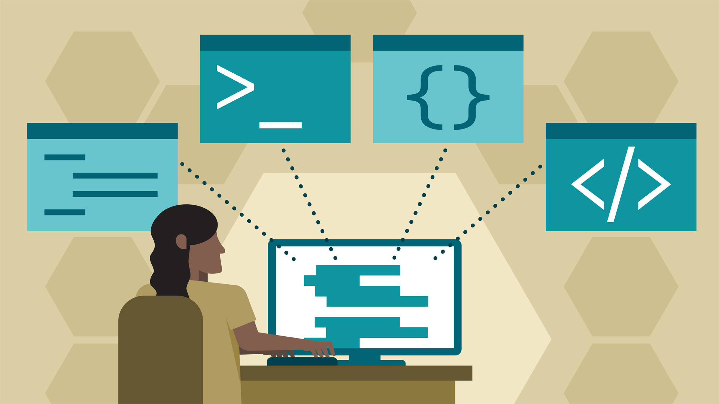

**Development process Plant Patrol**

**Luuk Vlug**

**500807974**

**luuk.vlug@hva.nl**

**Plan of development**

At the start of the project I only had the button and tried to come up with a good idea for my project using this button. This was prior to reading the study guide.. After reading the embedded section in the guide, I found out I needed to include a sensor AND a button. This created some panic. A week later, after doing some research and coming up with an idea, I got a DHT11 humidity sensor. With this sensor and some extra time on hand, I started doing some research and started in Arduino. I got the sensor to work, but was not sure what to do with this data. From others around me I heard people say they were trying to avoid using Firebase as it was for beginners. Me, being a beginner, decided to look into it. I asked around and heard it was not that easy to use. After a few weeks of doing research, trying libraries and different code and getting a new moisture sensor, I got it to work. After this I had a base to focus on web app for a while, so I did exactly that. Finished up my website, added some extra things and also included php for the button for input. I added some php code to Arduino and included a new library and got the button to work as well. After I got the button to work, I was satisfied with the outcome, and had around 3 weeks left before the (new) deadline. I started working on documentation. In around 3 days I made the documentation for embedded. The last thing to make was the development process. Overall I am happy with how things went, I got stuck for a few weeks on one thing, the Firebase connection. Other than that, everything went smooth and I learned quite a lot from the project in general.

**Resources used**

To solve the issues I encountered when displaying Firebase data on my website I used Stackoverflow. *Stackoverflow Questions*. (2020, 16 maart). Geraadpleegd op 16 maart 2020, van <https://stackoverflow.com/users/11101936/luukv19>

In the first week of struggling with the Firebase connection and data, I used an online guide for some information. A portion of the information was outdated, but it gave me an idea on how to get to work. ElectroPeak. (2019, 18 april). *Connecting Arduino to Firebase to Send & Receive Data*. Geraadpleegd op 12 maart 2020, van https://create.arduino.cc/projecthub/electropeak/connecting-arduino-to-firebase-to-send-receive-data-cd8805

Screenshot of the question I asked on Stackoverflow:

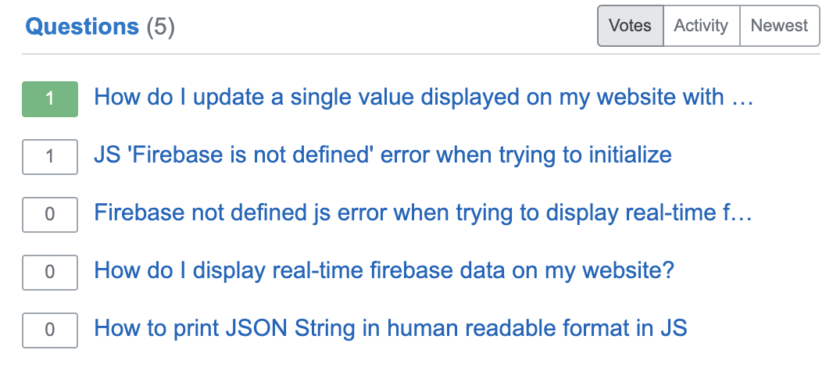

3 of the question are regarding the Firebase issue I had with displaying the values on my website. The biggest part about asking questions here was getting some example code back with methods I had not heard of before. Such as Stringify. This gave me the possibility to do research on this.

**New knowledge and acquired skills**

I had never worked with physical hardware like this, so everything on that front was new. Also learned a lot about Arduino and the libraries connected to it. From now on I know how to connect sensors and know the basics about programming them, which I think might come in useful later in life. I enjoyed the embedded and web app parts of the project and will definitely try more things with it after IoT is finished.